
Year 12 Human Biology
Unit 4: Test – Evidence for Evolution (5%)

Task 9
TYPE: Test
TIME: 50 minutes

Multiple Choice: 8 marks
Short Answer: 32 marks
Extended Answer: 6 marks
TOTAL 46 MARKS

Do not write on this question booklet
Do not turn page until instructed to do so

Section A: Multiple Choice (8 Marks)

Answer all questions by shading the most correct answer on the multiple choice answer sheet.

- Artefacts differ from fossils in that artefacts:

(a) are found associated with human remains
(b) are made of organic material that can be carbon dated
(c) are objects produced by hominins for a particular purpose
(d) are works of art with religious significance

Question 2 refers to the diagram below of the half-life of Potassium (K)-40.

- Potassium-40 decays into Argon-40. If a sample was found to be 3.2 billion years old, what approximate percentage of Argon-40 would be present?

(a) 80%
(b) 90%
(c) 60%
(d) 40%

- The main limitation of potassium-argon dating is that:

- it can only be used to date fossils over the age of 2 million years.
- it cannot be used to date fossils younger than 100,000 years old.
- it can only date sedimentary rocks.
- it can only date organic substances.

- The half-life of Carbon-14 is approximately:

(a) 10 430 years.
(b) 7250 years.
(c) 5730 years.
(d) 4780 years.

- Mitochondrial DNA is inherited from:

(a) both mother and father.
(b) only the father.
(c) only the mother.
(d) neither mother or father.

Question 6 and 7 refers to the diagram below.

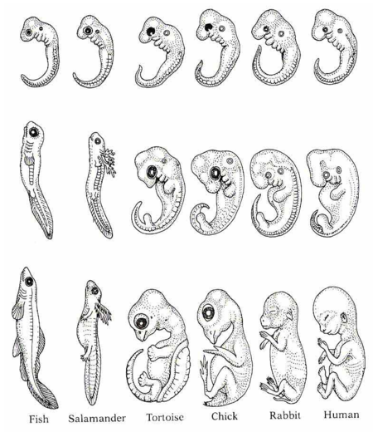

- The diagram above represents embryos of six (6) vertebrate species over several weeks’ development. The study of comparative embryology provides evidence of a common ancestor by noting that:

(a) the more closely two species are related, the later in development these differences arise.
(b) the more closely two species are related, the earlier in development these differences arise.
(c) the more distantly two species are related, the later in development these differences arise.
(d) the more distantly two species are related, the fewer differences will arise.

- The two vertebrates that have the most closely related ancestor are the:

- human and chick.
- human and tortoise.
- fish and salamander.
- salamander and rabbit.

Question 8 refers to the illustration below.

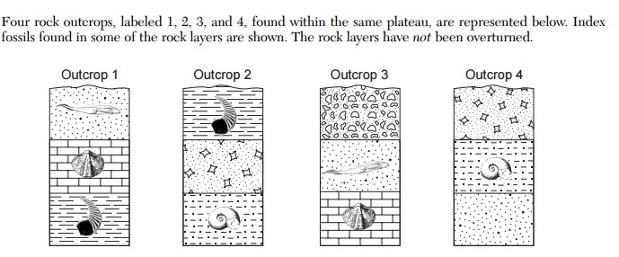

- Which of the following statements regarding the ages of the sedimentary rock layer outcrops is correct?

- Outcrop 1 is the oldest, Outcrop 2 is younger than 4.
- Outcrop 4 is the oldest, Outcrop 3 is younger than 1.
- Outcrop 2 is the oldest, Outcrop 3 is younger than 1.
- Outcrop 3 is the oldest, Outcrop 1 is younger than 4.

End of Section A


Year 12 Human Biology
Unit 4: Test – Evidence for Evolution (5%)

Name _________________________________________
Teacher_________________________________________
Task 8

TYPE: Test
TIME: 50 minutes

TOTAL /46 MARKS

Multiple choice & answer booklet

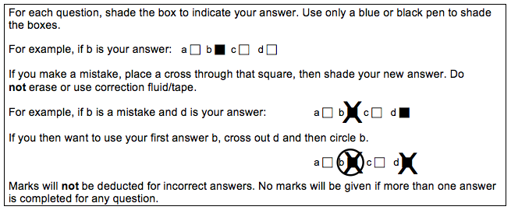

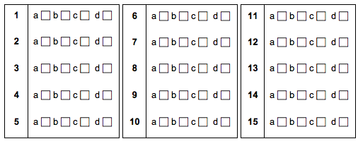
Section B: Short Answer (32 Marks)

Answer all questions in the spaces provided.
Question 9 (6 marks)

Use the diagram below to answer the following questions.

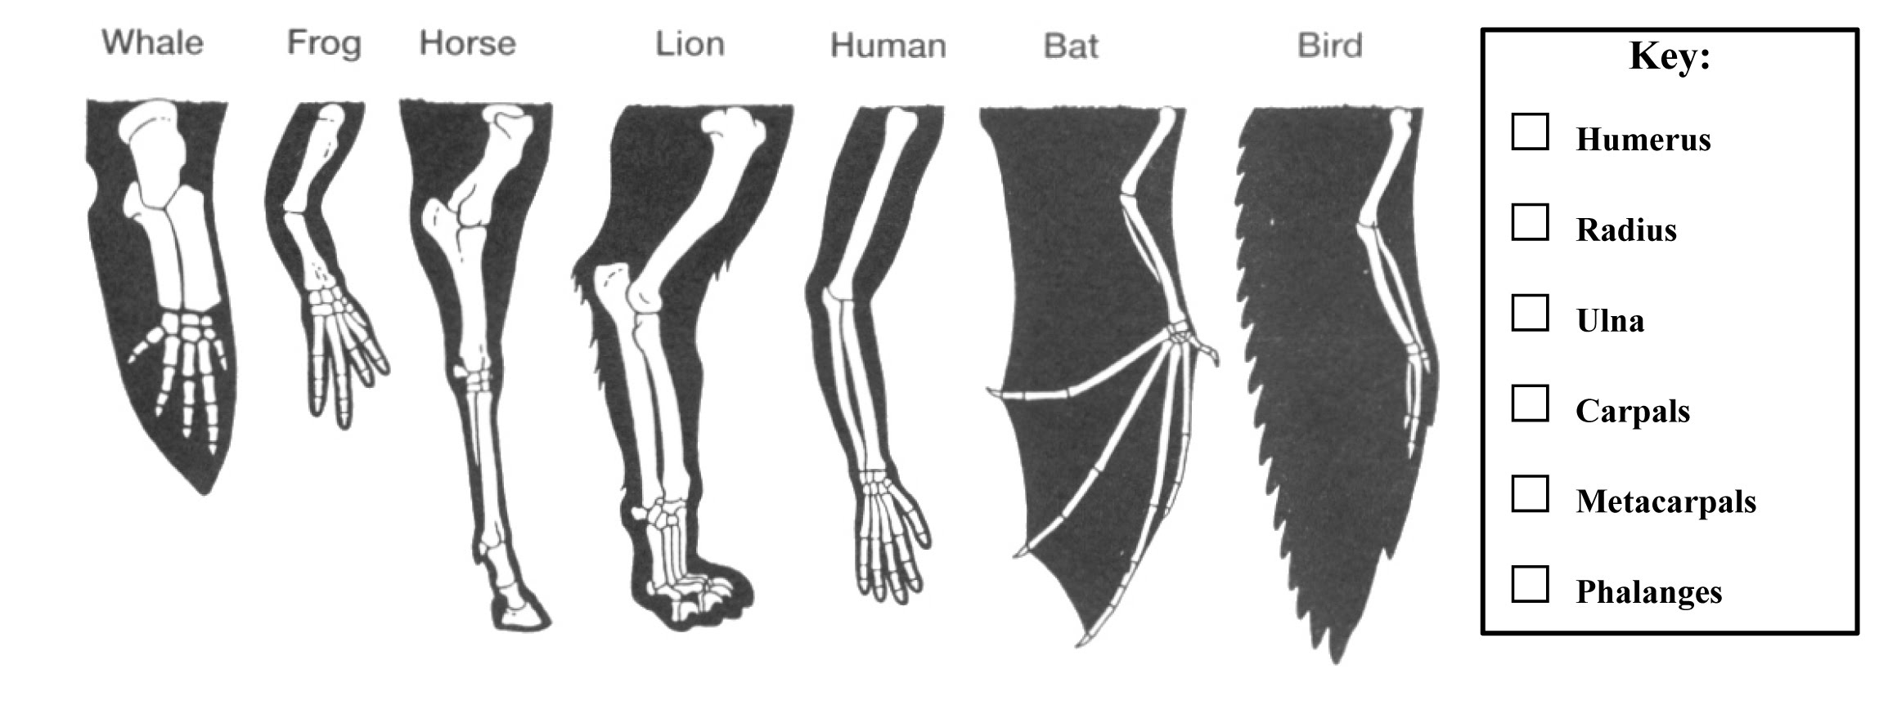

- Name the type of evidence of evolution shown in the diagram. (1 mark)

Name | Marks
Homologous structures | 1
Total | 1

- Explain how the diagram above provides evidence for evolution. Use specific examples in your response and reference relevant mechanisms of evolution. (5 marks)

Explain | Marks
Structure of the pentadactyl limb is the same across multiple specimens | 1
Similar structure but may have a different function | 1
Natural selection has selected the favourable trait for the environment (gradually altering the function of the limb) | 1
Bird/Bat use their limb for flying compared to Lion/Horse for locomotion/walking or human hand for grasping  - Any suitable example of comparison of speciments with different functions | 1
Provides evidence that the bat and the bird (or lion and horse) share a more recent common ancestor | 1
Total | 5

Question 10 (13 marks)

Archaeologists were comparing volcanic rock strata and found ancient tools in Germany that they believe belong to Homo neanderthalensis, an early human ancestor.

(a) Suggest which relative dating method could be used for these tools. (1 mark)

Name | Marks
Comparative Stratigraphy | 1
Total | 1

(b) Explain how archaelogists are able to provide an absolute date for these tools. In your response, name a radioimetric method which may be suitable. (3 marks)

Name | Marks
Potassium-Argon Dating/K-Ar dating | 1
Explain
The tools were found in volcanic rock which can be dated | 1
K-40 has a half life of 1.3 billion years | Any 1
Determine the proportion of K-40 to Ar to determine the age
Total | 3

Some fossils of Aboriginal people were found in Victoria, very close to a river. The fossils were dated and found to be 50,000 years old.

- Name and explain the process of the absolute dating method which would have been used to date these fossils. Include in your response how to calculate the age of the specimen using this technique. (6 marks)

Name | Marks
Carbon-14 | 1
Explain
Any three of:  - Plants absorb C14 during photosynthesis  - C14 is passed to animals through the food chain/description of animal eating plants  - Atmospheric ratio of C:14 to C:12 is 1 to 1 trillion respectively  - Measure C14 remaining in fossil  - Measure ratio of C14 remaining with C12 in fossil and compare with known atmospheric ratio | Any 3
Any two of:  - Half-life of C14 is 5730 years  - The amount of C14 left indicates the number of half-lives that have passed since death  - The number of half-lives is multiplied by 5730 to give age | Any 2
Total | 6

- The fossil record is incomplete and does not account for all of the organisms that have existed. Describe three reasons for the incomplete nature of the fossil record. (3 marks)

Description | Mark
Any three of the following
Fossilisation is rare/not all organisms have become fossils | Any 3
Very few of the fossils that exist have been discovered/Fossils have been destroyed (by industry or agriculture)
Accurate dating of fossils cannot always occur/carbon dating limited to organisms less than 60000 years old
Very few fossils of whole organisms exist/mostly fragments found
Total | 3

Question 11 (10 marks)

Comparative studies in anatomy and biochemistry can provide evidence of evolutionary relationships.

Parts (a) and (b) refer to the table below showing the differences in amino acids in the Cytochrome C protein sequence between humans and other species of animals.

Species compared with humans | Number of differences in amino acid sequence compared with human Cytochrome C
Chimpanzee | 0
Gorilla | 0
Rhesus monkey | 1
Rabbit | 9
Tuna fish | 21

  - Name an alternative/general term for proteins such as Cytochrome C. (1 mark)

Name | Marks
Ubiquitous Proteins | 1
Total | 1

  - Describe how this data can provide evidence for evolution. (3 marks)
Description | Marks
All living organisms have this (ubiquitous) protein | 1
Some of the amino acids (37) are found at the same positions in every sequenced cytochrome C molecule | 1
The more similarities between the number of the same amino acids the more recent the common ancestor/the less differences the further apart the ancestor | 1
Total | 3

  - Using wisdom teeth and body hair as examples, explain why these are considered vestigial organs and can provide evidence of evolutionary relationships. Include the definition of vestigial organs in your answer. (5 marks)

Definition | Marks
A structure of reduced size and no/changed function | 1
Explanation
Wisdom teeth
May have been used by ancestors to grind plant material when more prognathic/ ate plant based diet | 1
Too far back in jaw to be functional, can often become a problem and need to be removed | 1
Body hair
Would have been used to trap a layer of air to insulate the body against cold | 1
Body hair now too fine and hair not functional in this way | 1
Total | 5

  - Outline why vistigal ograns often reduce in size. (1 mark)

Outline | Marks
Reduce energy consumption | 1
Total | 1

Question 12 (3 marks)

Non-coding sequences of bases in the DNA have been termed “Junk DNA” as it was initially thought that they had no function.

- Name an example of “Junk DNA” which can be compared between specimens. (1 mark)

Name | Marks
Endogenous retroviruses | 1
Total | 1

- Outline how this provides evicence for evolution. (2 marks)

Outline | Marks
Organisms which possess more Junk DNA/ERVs in common share a more recent common ancestor | 1
Organisms which share fewer Junk DNA/ERVs have a more distant common ancestor | 1
Total | 2

End of Section B

Section C: Extended Answer (6 Marks)

Complete ALL of the following questions, and answer below.

Question 13

Discuss the importance of the fossil record in providing evidence for evolution. In your answer describe how fossils form. (6 marks)

Description | Marks
Any 2 of the following:  Importance:  (1) Many of the animal & plant fossils are unlike anything that are living today OR Present day forms are not preserved in the fossil record therefore we presume that they did not exist in the past  (1) Shows change over time and organisms becoming more complex  (1) Evidence of the missing link between species  (1) Can be used in conjunction with other evidence to support evolution ie. DNA/comparative anatomy etc. (must provide an example) | Any 2
Any 3 of the following:  How formed:  (1) Rapid burial by fine sediment/volcanic ash/mud  (1) Mineralisation: organic material replaced with minerals (in the soil/groundwater)  (1) Acidic soils and low oxygen for soft tissue and bone  (1) Alkaline soils (and low oxygen – don’t need again if mentioned above) for bone  (1) Preserved in amber  (1) not effected by plate tectonic movement  (1) trapped in ice with low temperatures  (1) low energy environment, lack of erosion, weathering ect (provide 1 example) | Any 4
Total | 6

